

Electric Vehicle Dealer Management SystemDocumentation

Members:

Full name ID

Nguyễn Tuấn Toàn SE194286

Mai Xuân Tín SE196519

Lê Kim Long SE182939

FUHCM, FALL 2025

TABLE OF CONTENTS

1 Introduction 3

1.1 Overview 3

1.2 Scope 3

1.3 References 3

2 Project scope 4

3 Scrum Process 5

4 FUNCTIONAL Requirements 6

4.1 Roles 6

4.2 Main Flows 7

4.3 Use Cases Diagram 7

4.4 Business Rules 8

5 NON-FUNCTIONAL Requirements 9

5.1 Usability 9

5.2 Reliability 9

5.3 Performance 9

5.4 Supportability 9

5.5 … 9

6 Screen Flow 10

7 Technologies 11

8 database design 12

8.1 [ERD] 12

8.2 [Database diagram] 12

9 source control 13

# Introduction

## Overview

The **Electric Vehicle Dealer Management System** focuses on building a platform to support the management of electric vehicle sales through dealer networks. Currently, dealerships face challenges in handling fragmented information such as vehicle catalogs, orders, promotions, and customer feedback.

This system is designed to:

* Enable dealers to easily access vehicle information, generate quotations, manage orders and contracts, track delivery progress, handle payments, and provide after-sales customer care.
* Allow manufacturers to better control distribution, monitor inventory, manage pricing and promotion policies for each dealer, and track sales performance across regions.

The ultimate goal is to create a centralized management system that reduces manual work, increases transparency, and enhances both business efficiency and customer experience.

## Scope

1.2.1 Actors

* **Dealer Staff**: Sales staff at the dealership.
* **Dealer Manager**: Managers at the dealership.
* **EVM Staff**: Staff from the vehicle manufacturer.
* **Admin**: System administrator.

1.2.2 Functional Scope  
1.2.2.1. Functions for Dealerships (Dealer Staff, Dealer Manager)

* **Vehicle Information**: Search vehicle catalogs, configurations.
* **Sales Management**: Create orders, manage promotions, manage payments (full payment/installments).
* **Customer Management**: Store customer profiles, test drive schedules, feedback, and complaints.

1.2.2.2. Functions for Manufacturer (EVM Staff)

* **Product & Distribution Management**: Manage vehicle catalog (models, versions, colors).

1.2.2.3. Functions for Admin

* **Account Management**: Manage accounts of staff members.

1.2.3 Project Boundaries

* Focus on managing sales and distribution of electric vehicles through dealerships.
* Does not cover manufacturing management.
* Does not include technical warranty or after-sales maintenance services (limited to customer care management).

1.2.4 Expected Outcomes

* A centralized management system that supports both dealerships and the manufacturer.
* Reduced manual work, improved transparency, and enhanced business efficiency.
* Better customer experience when interacting with dealerships.

## References

# Project scope

<System Context Diagram>

1. Purpose of the Context Diagram

A context diagram shows the **system as a single process** (the big circle in the middle) and how it interacts with external entities (actors). It defines **inputs and outputs** between the system and those actors, without going into internal details.

2. Main System

* The central process is:  
  **Electric Vehicle Dealer Management System**  
  → It handles the management of electric vehicle sales and dealer operations.

3. External Entities & Their Interactions

1. Dealer Manager
   * Provides and retrieves information such as:
     + Order Catalog Information / Query (manages orders).
     + Customer Catalog Information / Query (manages customer records).
     + *Promotion Information* (accesses promotion details).
     + *Test Drive Catalog Query* (retrieves test drive schedule).
2. Dealer Staff
   * Main interaction with the system for daily sales and customer service:
     + Vehicle Catalog Query / Information (search and view vehicle data).
     + Promotion Catalog Query / Information (view promotions).
     + *Customer Information* (record customer data).
     + *Order* (create and submit orders).
     + *Feedback Catalog Query / Information* (collect and view customer feedback).
3. EVM Staff (Manufacturer’s Staff)
   * Provides *Vehicle Information* to the system (about available models, versions, specs).
4. Admin
   * Manages user accounts:
     + *New Account* (create accounts for staff/managers).
     + Account Catalog Query / Information (manage account details).

# Scrum Process

https://fpt-team-o2ppprl3.atlassian.net/jira/software/projects/SCRUM/boards/1/backlog?atlOrigin=eyJpIjoiZTliYWI4YjVlMDBhNDY5ZWExZTAyOTUxNjhhNzAxYjEiLCJwIjoiaiJ9

# FUNCTIONAL Requirements

## Roles

* Dealer Staff:
  + Vehicle information query
  + Create order
  + Create reply for feedback
  + Create Payment
  + View Customer Information
  + View Test Drive
* Manager Staff
  + Manage Order
  + Manage Promotion
  + Manage Test Drive
  + Manage Customer
  + Manage Payment
  + Manage Feedback
* EVM Staff
  + Manage car
* Admin
* Manage User account

## Main Flows

* Flow 1: Dealer staff view and find detailed vehicle configuration and price

Ảnh có chứa biểu đồ, ảnh chụp màn hình, bản phác thảo, văn bản

Nội dung do AI tạo ra có thể không chính xác.

* Flow 2: Dealer Staff create Order and confirm by Manager Staff

Ảnh có chứa văn bản, biểu đồ, Phông chữ, ảnh chụp màn hình

Nội dung do AI tạo ra có thể không chính xác.

* Flow 3: Delaer Manager assign Staff to reply feedback

Ảnh có chứa Phông chữ, màu trắng, đen và trắng, văn bản

Nội dung do AI tạo ra có thể không chính xác.

## Use Cases Diagram

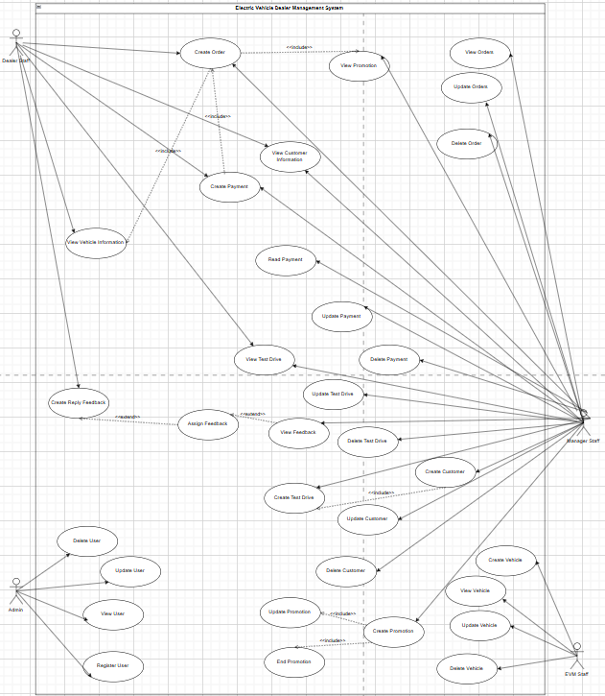

## Business Rules

Example:

|  |  |  |
| --- | --- | --- |
| **Rules** | **Descriptions** | **Notes** |
| **BR-01** | Each electric vehicle model must have a unique identifier and defined attributes (version, color, configuration, price). | Managed by EVM Staff/Admin. |
| **BR-02** | Dealers can only create quotations, orders, and contracts if the selected vehicle exists in dealer inventory (stock > 0). | Prevent overselling. |
| **BR-03** | Customers must confirm the order and choose a payment method (full payment or installment) before contract generation. | System auto-updates status. |
| **BR-04** | Installment purchases must include financing details (bank/credit institution, repayment schedule). | Required when payment_type = installment. |
| **BR-05** | Promotions must have start and end dates, and only valid promotions can be applied to quotes/orders. | Expired promotions cannot be applied. |
| **BR-06** | Dealer Managers can view customer lists, search by name/phone, and manage complaints/feedback. | Staff cannot edit complaints. |
| **BR-07** | EVM Staff manage vehicle catalog, wholesale price, and distribution to dealers. | Dealers cannot edit central catalog. |
| **BR-08** | Vehicles cannot be distributed to a dealer if central stock is insufficient. | Stock validation required. |
| **BR-09** | Dealers with overdue debts cannot place new orders. | Checked against debt records. |
| **BR-10** | Sales reports must be available by dealer, region, and sales staff. | Auto-generated periodically. |
| **BR-11** | Roles define access: Dealer Staff (sales), Dealer Manager (customers/reports), EVM Staff (distribution/products), Admin (system/accounts). | Enforced via role-based access control. |
| **BR-12** | All user actions (orders, distribution, complaints) must be logged for audit purposes. | Transparency & traceability. |
| **BR-13** | Each customer must have valid contact information (phone or email) before being stored in the system. | Prevents junk data. |
| **BR-14** | A customer cannot schedule a test drive without being assigned to a specific dealer. | Ensures accountability. |
| **BR-15** | A customer cannot schedule two test drives for the same vehicle model at the same dealer on the same day. | Prevents duplicate bookings. |
| **BR-16** | All orders must record creation date and current status (pending, confirmed, delivered, canceled). | For reporting and tracking. |
| **BR-17** | Only Admin can create, lock, or delete user accounts. | Account security. |
| **BR-18** | Locked (inactive) accounts cannot log into the system. | Applies to Dealer, Staff, EVM. |
| **BR-19** | Each sales contract must be uniquely linked to one order. | Ensures data integrity. |
| **BR-20** | If an order is canceled, related contracts and delivery schedules must also be canceled. | Keeps data consistent. |
| **BR-21** | The system must record history of updates (audit log) for critical entities: Orders, Contracts, Distribution, Promotions. | Compliance & monitoring. |
| **BR-22** | Dealers can only view customer and order information within their own dealership. | Data access restriction. |
| **BR-23** | When dealer inventory falls below a minimum threshold, the system must automatically alert the Dealer Manager. | Helps inventory management. |
| **BR-24** | Business reports must only include validated data (exclude canceled orders). | Ensures accuracy. |
| **BR-25** | For installment purchases, the customer can only receive the vehicle after loan approval by the financing institution. | Business rule for delivery. |
| **BR-26** | A promotion cannot be applied more than once to the same order. | Prevents abuse. |

# NON-FUNCTIONAL Requirements

[This section describes the non-functional requirements of the system. Some examples are listed as below]

## Usability

Clean and intuitive interface; each role sees only relevant modules.

## Reliability

The system should be able to handle and recover from errors without data loss or incorrect data processing.

## Performance

Support up to **50 concurrent users** (sufficient for demo/testing) with response times under **60 seconds**.

## Data Integrity

All transaction data (orders, payments, contracts) must maintain referential integrity. Updates must be atomic and logged.

## Security

Basic JWT-based login or hashed password authentication with role-based access (Dealer Staff, Dealer Manager, EVM Staff, Admin).

## Maintainability

The codebase should follow modular service-oriented architecture (Spring Boot + REST APIs) for easy updates and debugging.

# Screen Flow

Examples:

# Technologies

Ảnh có chứa văn bản, ảnh chụp màn hình, Phông chữ, biểu tượng

Nội dung do AI tạo ra có thể không chính xác.

# database design

## [ERD]

https://dbdiagram.io/d/68e90616d2b621e4223ffac4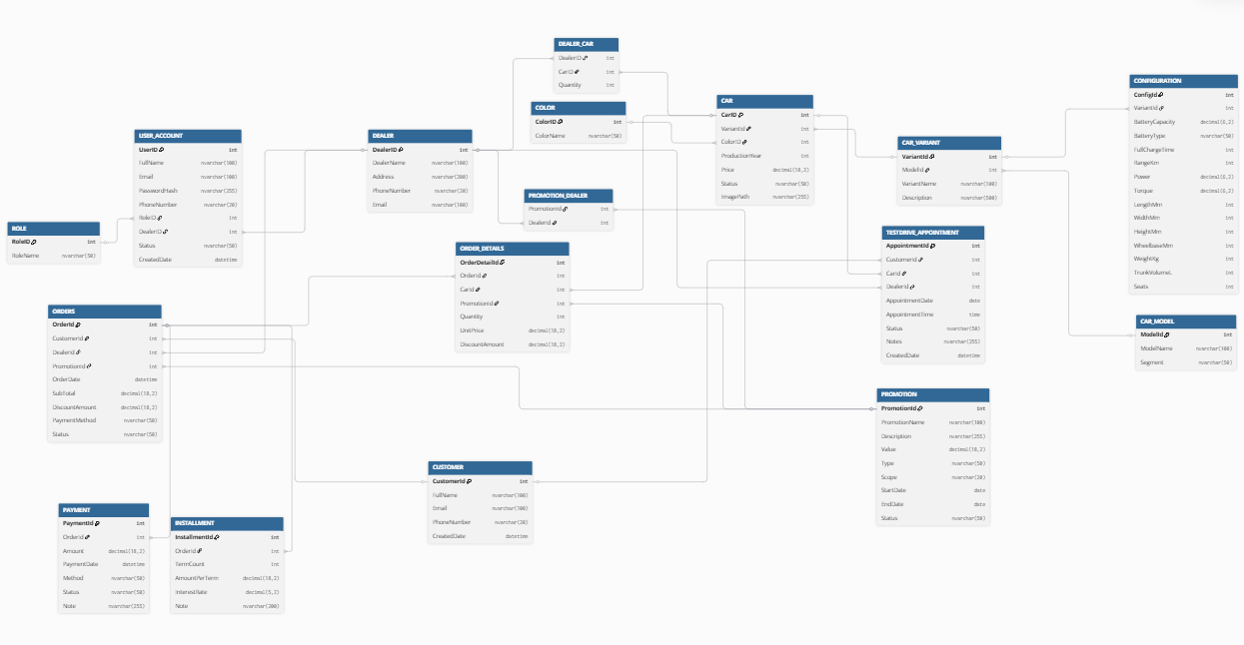

## [Database diagram]

https://github.com/Le-Kim-Long/Electric-Vehicle-Dealer-Management-System/blob/main/DB_EVM.sql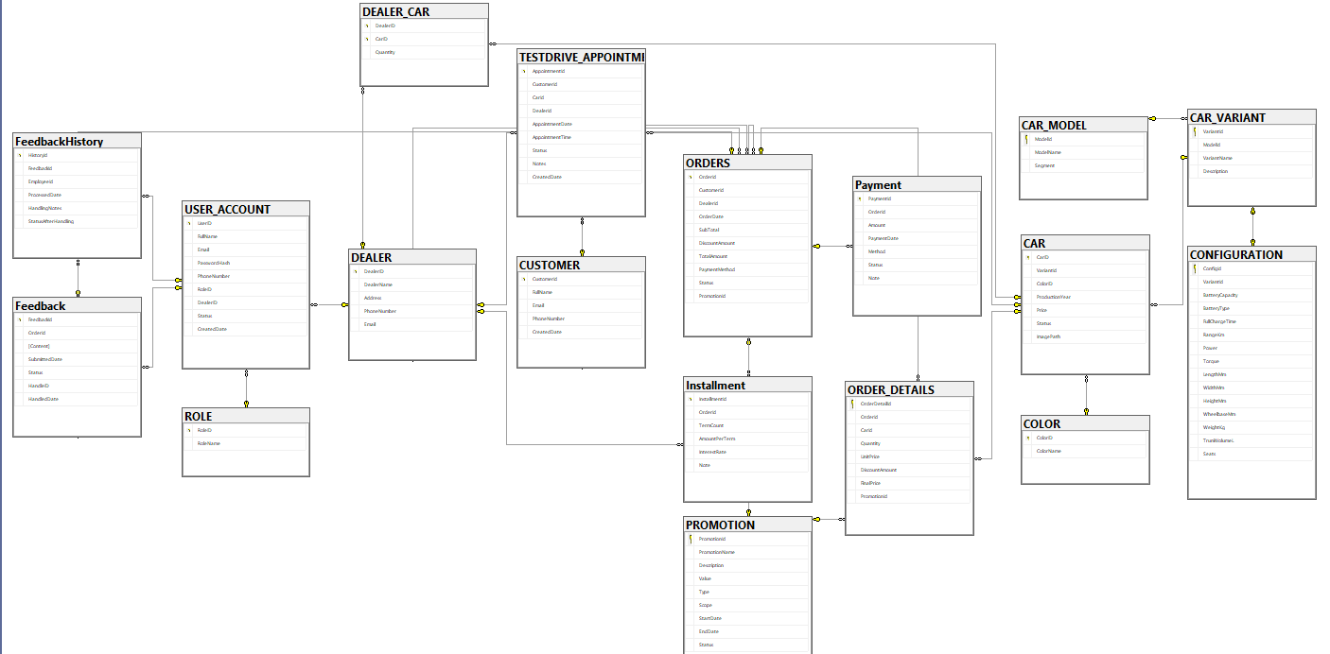

# source control

**Github link:** https://github.com/Le-Kim-Long/Electric-Vehicle-Dealer-Management-System